Are you ready for new ways of work in the collaborative design process?
From a raw product idea to the conceptual design
COnCEPT platform supports the creation of the necessary collaborative environment to enhance designer creativity, facilitates interactions in distributed and multidisciplinary teams and increases the efficiency and quality of the outputs at the early stages of industrial design process, the conceptual design.
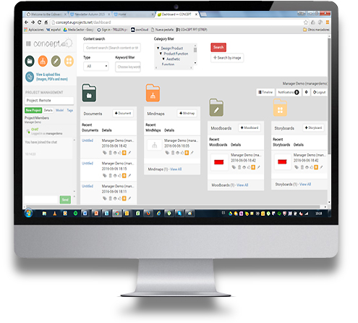
Look at key COnCEPT features for you!
Simplicity and asset management - During the creative process, face to face sessions are organised and generate a large number of ideas or artefacts that are captured such as hand-made sketches, diagrams, drawings, images, models, etc. For instance, images are a powerful mechanism to convey emotions and capture experiences. COnCEPT incorporates a semantic annotation indexer together with a media database allow storing enriched artefacts (adding text, captions, date, context information, etc.) that can be searched and re-used in multiple processes
Integration - the global asset management (pictures, designs, sketches, conceptual maps, etc) is achieved in COnCEPT by embracing a Contend Management System (CMS) as necessary integration glue among the different tools.
Efficiency - First stages of design are highly interactive but also involve a great many systematic processes to be accomplished. COnCEPT supports this process with a project management software that allows organizing the overall activity, project timeline and assigning tasks to users to works against expected results and deadlines.
Flexibility and Easy to Use - The conceptual process has collaborative activities such a brainstorming, sketching and post analysis of ideas to organise them. These supporting techniques are the means to achieve maximum creativity and to increase the quality and quantity of ideas, solving problems or generating new products. COnCEPT by means of a modular approach integrates concrete tools such as for mind mapping and creating storyboards, offering an enhanced support with a consistent data model across the tools.
COnCEPT Platfrom demo already available at:
http://concept.euprojects.net

